**Web Technology for bioinformatics**

Name - Dharineesh K S Date - 13/10/2021

Regno - 123013012 Ex.no - 03

**Aim:**

To create an online course log entry using PHP MySQL

**Requirements in the application:**

Mysql Database and PHPmyadmin

**Details of Online Course Log entry :**

In SASTRA University , Online course log entry was available for faculty members for entering the details of video lectures in the portal for a particular course on a daily basis. The entry details are :

* Topic
* Video Link
* Duration in minutes

**Steps for creating following database and tables for the Online Course Log Application:**

* First create the database named “sastradb”.
* Next create the faculty table named “faculty list” in the sastradb database with the following fields : Facultyid, faculty name, password, department
* Insert at least two entries into the faculty list table.
* Next create the “videolectures” table with the following fields: Topic, Video Link, Duration in minutes, faculty id.
* Don’t insert any values into the videolectures table. It will be used at the runtime.

**Coding segment:**

* Create the Login form to get the faculty ID and password(login.php) .
* Verify the username and password and display the course log entry form for the faculty who logged in successfully (usercheck.php).
* Get the course log details and sent to a PHP script for inserting the values into the
* database(insertvideo.php).
* Create a hyperlink in the page on the usercheck.php page to display the video lectures details entered by the faculty.

**Program:**

**The code below is written in a php file(login.php):**

<!DOCTYPE html>

<head>

<title>Login form</title>

<style>

.tb{

background-color: burlywood;

}

body{

background-color: rgba(8, 10, 146, 0.959);

margin-top: 9%;

margin-bottom: 9%;

}

td{

background-color: cornflowerblue;

}

</style>

</head>

<body>

<form method="POST" action="usercheck.php">

<table border=1 align="center" class="tb">

<tr>

<td align="center">

<br>

<br>

<br>

<center>

<img src="https://webstream.sastra.edu/sastrapwi/images/sastra_logo_1.gif" width="70%">

</center>

<br>

<hr>

SASTRA DEEMED UNIVERSITY<br>

Tirumalaisamudram<br>

Thanjavur - 613401<br>

Tamilnadu, India

</td>

<td align="center">

<h3>eVarsity</h3>

<h3>ERP for education</h3>

<br>

<hr>

<h3>Enter the user id and password to login</h3>

<table>

<tr>

<th align="right">

Your ID:

</th>

<td>

<input type = "text" name = "userid" placeholder = "user id">

</td>

</tr>

<tr>

<th align="right">

Your Password:

</th>

<td>

<input type=password name="pwd" placeholder = 'password'>

</td>

</tr>

<tr>

<td colspan="2" align = "center">

<?php

echo "<style>

h4{

background-color : red;

}

</style>";

if (isset($_GET['value']))

{

echo "<h4>Invalide user id or password </h4>";

}

?>

</td>

</tr>

<tr>

<td colspan="2" align="center">

<input type=submit value="Log in">

</td>

</tr>

</table>

</td>

</tr>

</table>

</form>

</body>

</html>

**Output of php script(login.php):**



**If userid or password invalide:**



**The code below is written in a php file(usercheck.php):**

**<?php**

**/\***

**Author : Dharineesh K S**

**Regno : 123013012**

**\*/**

**echo "**

**<html>**

**<head>**

**<title>Forms</title>**

**<link rel=\"stylesheet\" href=\"https://www.w3schools.com/w3css/4/w3.css\">**

**</head> ";**

**if(isset($_POST["pwd"]))**

**{**

**$uid= $_POST["userid"];**

**$pwd= $_POST["pwd"];**

**$connection = mysqli_connect("localhost","root","")or die(mysql_error());**

**mysqli_select_db($connection,"sastradb")or die(mysql_error());**

**$sql="select * from facultylist where Facultyid='$uid' and password='$pwd'";**

**$query = mysqli_query($connection,$sql) or die(mysql_error());**

**$num=mysqli_num_rows($query);**

**echo "<body>";**

**if($num==1)**

**{**

**echo "<center>Login successfull</center> <br>";**

**echo "<center>**

**<div class=\"w3-dropdown-hover\">**

**<button class=\"w3-button w3-green\">select</button>**

**<div class=\"w3-dropdown-content w3-bar-block w3-border\">**

**<a href=\"insertvideo.php?userid=$uid\" class=\"w3-bar-item w3-button\">Course log entry</a>**

**<a href=\"showcourselog.php?userid=$uid\" class=\"w3-bar-item w3-button\">Generate Report</a>**

**</div>**

**</div></center> " ;**

**}**

**else**

**{**

**header("location:login.php?value='Invalide'");**

**}**

**}**

**else**

**{**

**$id = $_GET['userids'];**

**echo "<center></center> <br>";**

**echo "<center>**

**<div class=\"w3-dropdown-hover\">**

**<button class=\"w3-button w3-green\">select</button>**

**<div class=\"w3-dropdown-content w3-bar-block w3-border\">**

**<a href=\"insertvideo.php?userid=$id\" class=\"w3-bar-item w3-button\">Course log entry</a>**

**<a href=\"showcourselog.php?userid=$id\" class=\"w3-bar-item w3-button\">Generate Report</a>**

**</div>**

**</div></center> " ;**

**}**

**echo"</body>";**

**echo"</html>";**

**?>**

**Output of php script(usercheck.php):**

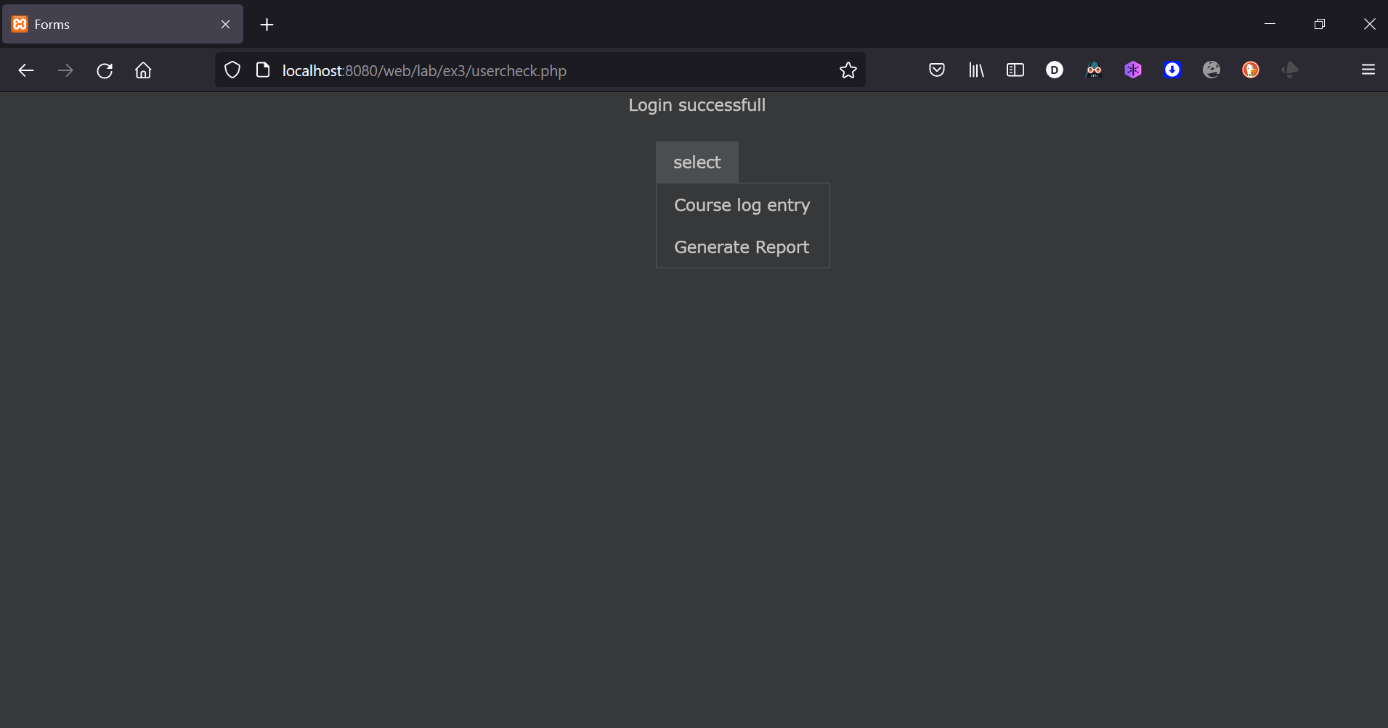

**The code below is written in a php file(insertvideo.php):**

**<?php**

**/\***

**Author : Dharineesh K S**

**Regno : 123013012**

**\*/**

**echo "**

**<html>**

**<head>**

**<title>Course log entry form</title>**

**<style type=\"text/css\">**

**body {**

**font-family: \"Times New Roman\";**

**}**

**</style>**

**</head> ";**

**echo "<body>";**

**$uid = $_GET['userid'];**

**echo "<form method=post action = 'courselogentry.php?userid=$uid'>**

**Topic <br> <textarea name=topic rows=5 cols=20 ></textarea><br>**

**Video link <br><input type=text name=vlink size=50><br>**

**Duration(min) <br><input type=text name=duration placeholder=0><br>**

**<input type=submit value=Save> </form>";**

**echo"</body>";**

**echo"</html>";**

**?>**

**Output of php script(insertvideo.php):**

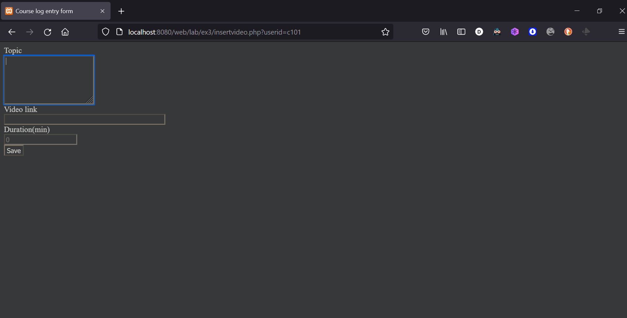

**The code below is written in a php file(courselogentry.php):**

**<?php**

**/\***

**Author : Dharineesh K S**

**Regno : 123013012**

**\*/**

**echo "**

**<html> <head>**

**<title>successfully Submitted</title>**

**<style type=\"text/css\">**

**body { font-family: \"Times New Roman\"; }**

**</style> </head> ";**

**echo "<body>";**

**$topic = $_POST['topic'];**

**$vlink = $_POST['vlink'];**

**$duration = $_POST['duration'];**

**$uid = $_GET['userid'];**

**$connection = mysqli_connect("localhost","root","")or die(mysql_error());**

**mysqli_select_db($connection,"sastradb")or die(mysql_error());**

**$sql="insert into videolectures values ('$topic','$vlink',$duration,'$uid')";**

**mysqli_query($connection,$sql);**

**echo" Video links was added successfully <br>";**

**echo "<a href = 'usercheck.php?userids=$uid '>press here to go back</a>";**

**echo"</body>";**

**echo"</html>";**

**?>**

**Output of php script(courselogentry.php):**

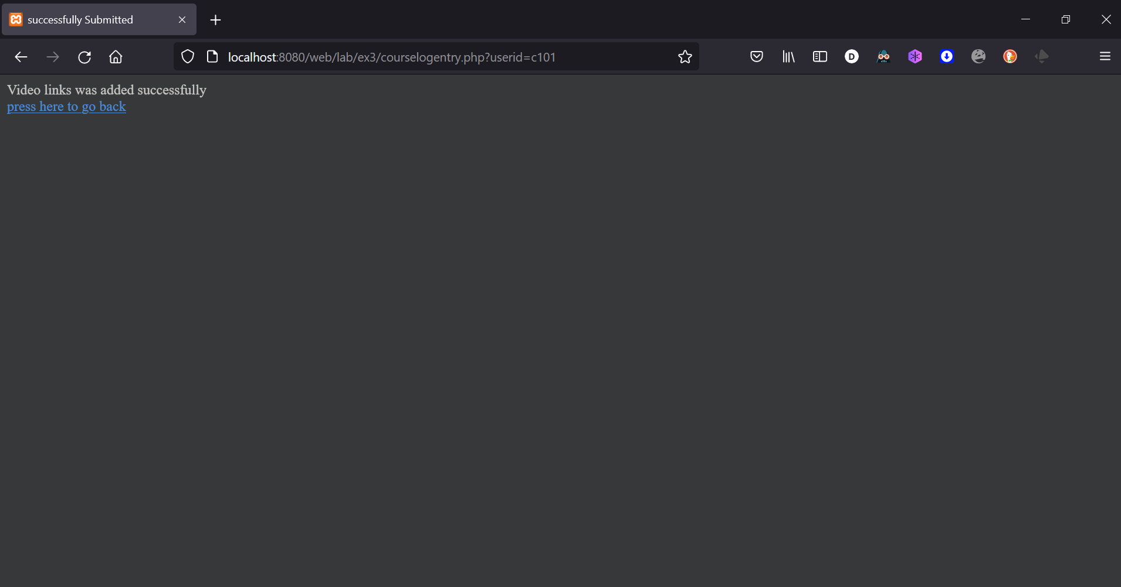

**If click (please here to go back) link, it redirects to forms page:**

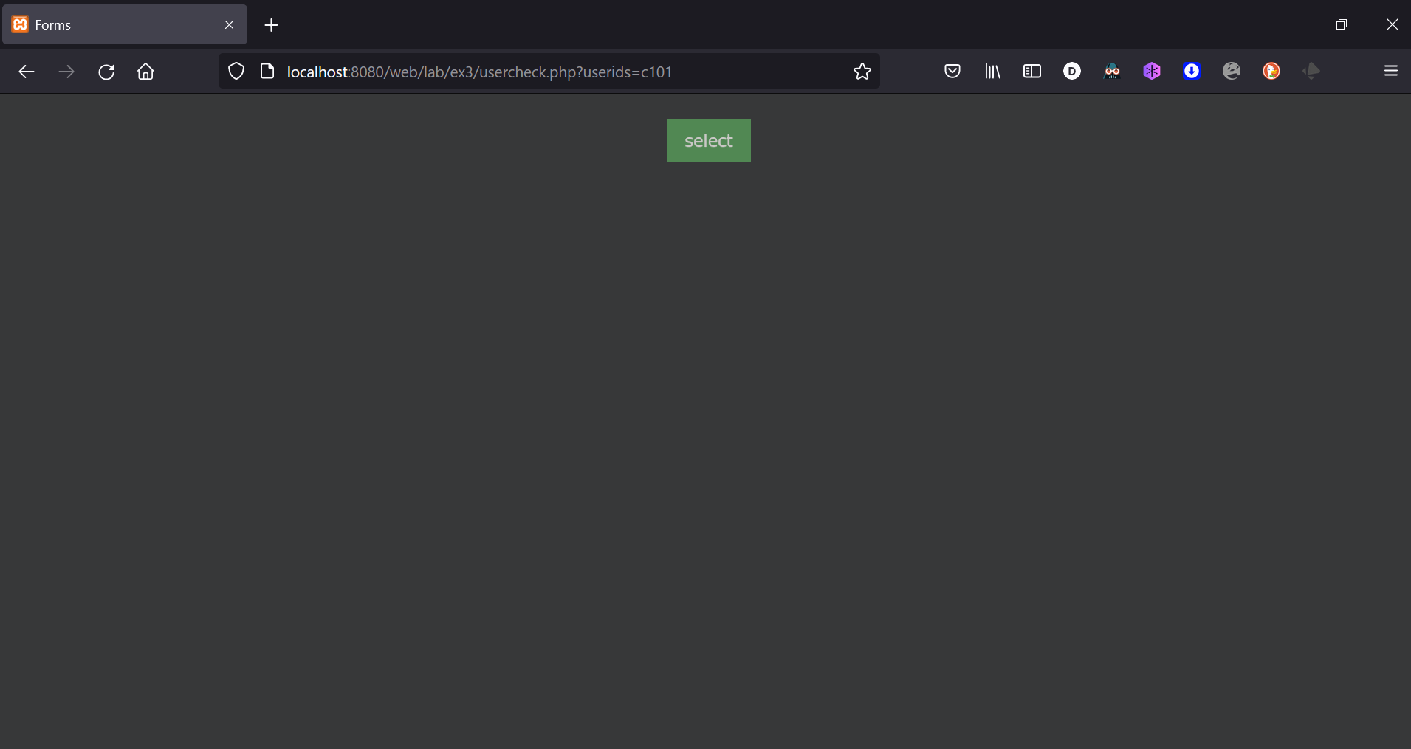

**The code below is written in a php file(showcourselog.php):**

**<?php**

**/\***

**Author : Dharineesh K S**

**Regno : 123013012**

**\*/**

**echo "**

**<html>**

**<head>**

**<title>Generate Report</title>**

**<style type=\"text/css\">**

**body {**

**font-family: \"Times New Roman\";**

**}**

**table {**

**width: 50%;**

**}**

**tr:nth-child(even) {**

**background-color: #f2f2f2 ;**

**}**

**</style>**

**</head> ";**

**echo"<body>";**

**$uid = $_GET['userid'];**

**$connection=mysqli_connect("localhost","root","")or die(mysql_error());**

**mysqli_select_db($connection,"sastradb")or die(mysql_error());**

**$sql="select * from videolectures where Facultyid='$uid'";**

**$query = mysqli_query($connection,$sql) or die(mysql_error());**

**echo "<table align='center'><tr><th>Topic</th><th>video link</th><th>Duration in minutes</th></tr>";**

**while($row = mysqli_fetch_array($query))**

**{**

**$topic = $row['Topic'];**

**$vlink = $row['Video Link'];**

**$duration = $row['Duraton in minutes'] ;**

**echo "<tr><td>$topic</td><td>$vlink</td><td align='center'>$duration</td></tr>";**

**}**

**echo"</table>";**

**echo"</body>";**

**echo"</html>";**

**?>**

**Output of php script(showcourselog.php):**

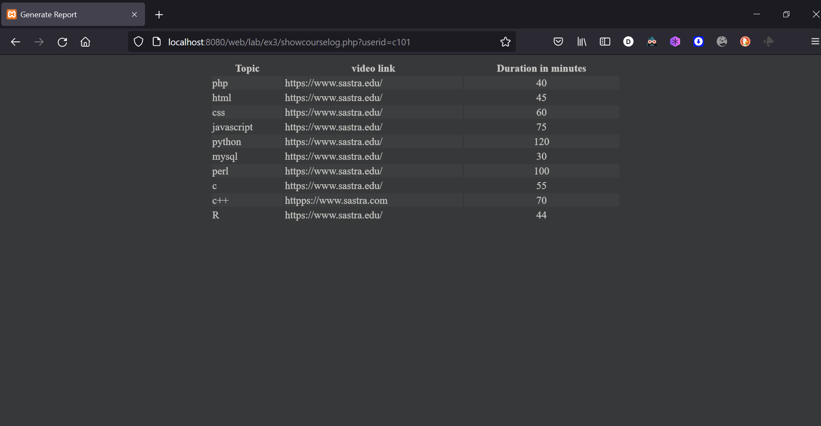

**Result:**

Hence, successfully created an online course log entry using PHP and MySQL.